
DEVELOPMENT OF A CUSTOM SIEM SYSTEM WITH REAL-TIME THREAT DETECTION AND ALERTING
SEMINAR REPORT
SUBMITTED BY:
SAI KRISHNA
THANUSREE
GOWTHAMARAJ
PREFACE

In the modern digital landscape, organizations are under constant threat from a wide array of cybersecurity challenges, including unauthorized access, data breaches, and insider threats. To address these challenges proactively, Security Information and Event Management (SIEM) systems have become a critical component in any organization’s security infrastructure.
This project focuses on the design and development of a custom SIEM (Security Information and Event Management) system that enables real-time threat detection, alerting, and visualization. Unlike large-scale commercial solutions, this lightweight SIEM is built using open-source tools, making it accessible and affordable for small businesses, academic environments, and security enthusiasts.
Interns working on this project gain practical experience with log collection, event correlation, real-time analysis, and dashboard visualization using technologies such as Filebeat, Logstash, Elasticsearch, Kibana, and Python scripting. Additionally, the project introduces alerting systems and testing simulations to prepare for real-world incident detection and response scenarios.
- Chapter 1 introduces the fundamentals of SIEM systems, key concepts in log analysis, and the open-source tools used throughout the project.
- Chapter 2 outlines the problem statement, project objectives, and both functional and non-functional requirements.
- Chapter 3 presents the system architecture and design aspects, including block diagrams, data flow diagrams, and process descriptions.
- Chapter 4 focuses on implementation and testing, showcasing test cases for log ingestion, detection logic, and alert generation.
- Chapter 5 highlights the results, including screenshots of dashboards, alert notifications, and data insights with detailed explanations.
- Chapter 6 provides setup instructions, environment configuration steps, and all necessary dependencies to replicate and run the project successfully.

ABSTRACT
In today’s increasingly connected world, organizations face a growing number of cybersecurity threats originating from both internal and external sources. From brute-force login attempts to unauthorized access and malicious insider activity, the ability to monitor and respond to such threats in real-time is critical. While enterprise-grade SIEM (Security Information and Event Management) solutions offer extensive capabilities, they often come with high costs and complexity, making them less accessible to smaller organizations, academic institutions, or independent security teams.
This project introduces a lightweight, open-source SIEM system designed to collect, analyze, and visualize security logs from multiple sources in real-time. The system leverages the ELK stack (Elasticsearch, Logstash, Kibana) along with tools like Filebeat and Auditd to ingest and index data from Linux-based servers. Built-in detection logic and alerting mechanisms notify administrators of suspicious behavior through channels such as email and Discord webhooks.
Interns participating in this project gain practical experience in:
- Log collection and aggregation from various sources
- Event correlation and detection rule creation
- Security dashboard development using Kibana
- Real-time alerting system configuration
- Documentation and testing under real-world attack simulations
This hands-on project not only develops technical proficiency in SIEM operations but also prepares interns for real-world roles in security operations centers (SOCs), detection engineering, and cybersecurity infrastructure management.

LIST OF FIGURES

S.NO | TITLE | PAGE NUMBR
1 | FIGURE 1.1 | 15
2 | FIGURE 1.2 | 17
3 | FIGURE 1.3 | 20
4 | FIGURE 1.4 | 21
5 | FIGURE 1.5 | 21
6 | FIGURE 1.6 | 22
7 | FIGURE 1.7 | 23
8 | FIGURE 1.8 | 23
9 | FIGURE 1.9 | 24
10 | FIGURE 2.0 | 24
11 | FIGURE 2.1 | 24
12 | FIGURE 2.2 | 25

TABLE OF CONTENTS

S.NO | CONTENTS | PAGE NUMBERS
1. | PREFACE | 2
2. | ABSTRACT | 3
3. | LIST OF FIGURES | 4
4. | INTRODUCTION | 6-9
5. | SOFTWARE REQUIREMENT SPECIFICATION | 10-13
6. | DESIGN | 14-17
7. | TESTING | 18-19
8. | RESULTS | 20-25
9. | DEPLOYMENT | 26-27
10. | CONCLUSION | 28
11. | FUTURE SCOPE | 29
12. | REFERENCE | 30-31
13. | APPENDIX | 32-33

CHAPTER1:INTRODUCTION
1.1 INTRODUCTION TO CUSTOM SIEM SYSTEM WITH REAL-TIME THREAT DETECTION
As the complexity and frequency of cyber threats continue to grow, organizations must move beyond reactive security practices toward proactive threat monitoring and response. Traditional log management tools often lack the capabilities required to detect, analyze, and act upon suspicious activity in real-time. This creates a critical gap in an organization’s ability to prevent security incidents.
Security Information and Event Management (SIEM) systems address this challenge by providing centralized log collection, real-time monitoring, event correlation, and alerting across distributed systems. However, commercial SIEM solutions are often expensive, resource-intensive, and difficult to tailor to specific use cases—making them inaccessible to small organizations, educational institutions, or security-focused research teams.
This project introduces a lightweight, open-source SIEM system designed to monitor and detect cybersecurity threats in real-time. The system is built using the ELK stack (Elasticsearch, Logstash, and Kibana), along with data shippers like Filebeat and Auditd, and supports alerting mechanisms via ElastAlert and Discord webhooks.
Key features of the system include:
- Centralized Log Ingestion: Collects logs from various sources, including SSH, Apache, and system audit logs.
- Real-Time Threat Detection: Identifies anomalies and suspicious patterns based on predefined rules.
- Interactive Dashboards: Visualizes login attempts, IP geolocation heatmaps, and trends using Kibana.
- Alerting Mechanism: Sends notifications for potential security events via email or messaging services.
- Attack Simulation and Testing: Validates the system by simulating real-world attack scenarios.
- Complete Documentation: Includes configuration guides, system architecture, and user instructions.
Developed with a focus on usability, flexibility, and extensibility, this custom SIEM solution serves as a hands-on learning platform for security engineers, developers, and interns. It provides a foundational understanding of log analysis, threat detection, and incident response within a real-time monitoring environment.

1.2 METHODOLOGY USED
The Custom SIEM System follows a structured and modular methodology to monitor, detect, and alert on suspicious activities in real-time. The system begins by installing and configuring log forwarders like Filebeat and Auditd on Linux servers, which collect logs from sources such as SSH authentication, Apache web access, and system events.
These logs are forwarded to Logstash, where they are parsed, filtered, and enriched with metadata. The processed logs are then indexed and stored in Elasticsearch, making them searchable and ready for visualization. The Kibana interface enables users to explore the data through dashboards that display login attempts, IP heatmaps, and activity timelines.
To enhance threat detection, ElastAlert is used to define custom alerting rules. When suspicious patterns such as brute-force attempts or foreign IP access are detected, alerts are triggered and sent via email or Discord webhook.
This end-to-end process allows users to monitor system behavior, identify anomalies, and respond proactively. Interns interact with every stage—from setting up log collectors to defining detection rules and designing dashboards—thereby gaining hands-on experience in real-world SIEM operations.

1.3 TECHNOLOGY USED
To ensure a robust, flexible, and scalable SIEM platform, this project integrates widely-used open-source technologies. Each tool was selected based on its ability to handle real-time data processing, storage, visualization, and alerting. The technologies used are described below.

1.3.1 FILEBEAT
Filebeat is a lightweight log shipper that monitors and forwards log files to Logstash or Elasticsearch. In this project, Filebeat is configured on client machines to collect:
- SSH authentication logs (/var/log/auth.log)
- Apache server access logs
- System event logs
Advantages:
- Low resource consumption, ideal for continuous logging
- Predefined modules for common log types (e.g., Apache, system)
- Seamless integration with Logstash and Elasticsearch
Filebeat plays a critical role in gathering and transporting real-time logs for further analysis.

1.3.2 LOGSTASH
Logstash is used to parse and enrich the raw logs received from Filebeat before storing them in Elasticsearch. Custom pipelines are created using grok filters to extract structured fields from unstructured data.
Responsibilities:
- Parse and normalize logs from different sources
- Add metadata (e.g., geoIP, timestamps)
- Route logs to Elasticsearch for indexing
Logstash enables event correlation and supports filtering logic to highlight significant security events.

1.3.3 ELASTICSEARCH
Elasticsearch is the central data store where all processed logs are indexed and stored. It supports full-text search, filtering, and aggregations across massive volumes of log data in real-time.
Features:
- Scalable and distributed architecture
- Fast search and query capabilities
- Supports complex queries and filters for detection rules
All logs, alerts, and trends are stored and analyzed within Elasticsearch, forming the core of the SIEM.

1.3.4 KIBANA
Kibana is a powerful frontend interface for visualizing data stored in Elasticsearch. Interns use Kibana to build interactive dashboards showing:
- SSH login attempts
- Failed login trends
- IP-based geolocation heatmaps
- Timeline of alerts and system behavior
Benefits:
- Drag-and-drop interface for visualizations
- Real-time updates from log streams
- Customizable filters, date ranges, and user views
Kibana transforms complex data into actionable insights via clean and dynamic visualizations.

1.3.5 ELASTALERT
ElastAlert is used for defining and managing real-time detection rules. It continuously queries Elasticsearch for specific patterns and generates alerts when matching conditions are found.
Alerting Scenarios:
- Multiple failed logins within a short time
- Access from blacklisted or foreign IPs
- Apache 500 error spikes
Notification Methods:
- Email alerts (SMTP)
- Discord Webhook integration for team collaboration
ElastAlert adds automation and response capabilities to the SIEM by enabling early threat detection.

1.3.6 PYTHON & BASH
Scripting is used to automate tasks, simulate attacks, and create utility functions.
- Python: For writing custom scripts, rule templates, log processors, and ElastAlert configurations.
- Bash: For automating deployment, setting up services, and simulating log generation.
These scripts streamline the SIEM setup and testing process, improving efficiency and reproducibility.

CHAPTER 2 PROBLEM IDENTIFICATION

2.1 PROBLEM STATEMENT
Modern IT infrastructures generate massive volumes of log data from diverse sources—network devices, servers, applications, and endpoints. Manually monitoring and analyzing these logs is impractical, leaving systems vulnerable to cyber threats such as brute-force attacks, privilege escalation, insider threats, and misconfigurations. While commercial SIEM solutions exist, they are often expensive and complex, making them inaccessible to small organizations and academic users.
This project aims to develop a lightweight, open-source SIEM (Security Information and Event Management) system that collects, analyzes, and detects security events in real-time using rule-based alerts and intuitive dashboards.
2.2 PROJECT SCOPE
This project delivers a scalable and user-friendly SIEM solution with the following scope:
- Log collection from Linux systems using Auditd and Filebeat.
- Centralized storage and indexing using Elasticsearch.
- Real-time log parsing and enrichment using Logstash.
- Predefined detection rules (YAML) for common attacks like brute force, account misuse, unauthorized sudo attempts, etc.
- Visual dashboards and filtering using Kibana.
- Alert generation via ElastAlert and notifications via email or Discord.
- Designed for students, cybersecurity trainees, and small organizations.

2.3 DESIGN AND IMPLEMENTATION CONSTRAINTS
Technology Stack: ELK Stack (Elasticsearch, Logstash, Kibana), Filebeat, Auditd, ElastAlert, Python.
Rule-Based Detection: Uses static YAML rules instead of ML or behavioral analytics.
Platform Constraint: Primarily designed for Linux-based systems (Ubuntu/Debian).
Real-Time Constraints: Alerting may have up to a few seconds delay depending on log ingestion.

2.4 USER DOCUMENTATION
The user documentation will include:
- Setup instructions for Elasticsearch, Logstash, and Kibana.
- Guide for installing Filebeat and Auditd on endpoints.
- Instructions to enable and test pre-written detection rules.
- How to interpret alerts and Kibana dashboards.
- Troubleshooting common issues.

2.5 ASSUMPTIONS AND DEPENDENCIES
- The user has administrative access to configure servers and services.
- Network and firewall configurations allow traffic between agents and the ELK stack.
- Required ports (9200, 5044, 5601) are open.
- Python, pip, and necessary packages are installed for ElastAlert.
- The system is not heavily resource-constrained.

2.6 SYSTEM FEATURES
The SIEM system will provide the following core features:
- Centralized log collection from multiple endpoints.
- Preprocessing and filtering of logs.
- Alert generation for:
  - Brute-force and failed SSH logins
  - Unauthorized sudo attempts
  - Privileged account creation
  - Multiple password resets
  - Account lockouts
- Interactive dashboards in Kibana.
- Real-time notifications via email/Discord.

2.6.1 ACTORS
User (Security Analyst/Admin): Views dashboards, receives alerts, monitors activity.
System: Collects, processes, and correlates log data from monitored sources.

2.7 FUNCTIONAL REQUIREMENTS
2.7.1 DATA COLLECTION
- Filebeat collects logs from endpoints.
- Auditd records Linux audit events (authentication, user activity).
2.7.2 EVENT CORRELATION & DETECTION
- ElastAlert reads logs from Elasticsearch and applies YAML detection rules.
2.7.3 DASHBOARD VISUALIZATION
- Kibana provides dashboards for failed logins, sudo activity, user changes, etc.
2.7.4 ALERTING SYSTEM
- Alerts triggered are delivered via email, Slack, or Discord.

2.8 NON-FUNCTIONAL REQUIREMENTS
2.8.1 USER NON-FUNCTIONAL REQUIREMENTS
- Interface must be simple enough for students or junior analysts to understand.
- Minimal manual configuration required once deployed.
2.8.2 SYSTEM NON-FUNCTIONAL REQUIREMENTS
- System must process logs in near real-time (delay <10 seconds).
- Must handle logs from at least 5–10 servers concurrently.
2.8.3 OTHER NON-FUNCTIONAL REQUIREMENTS
- Modular rule files (YAML) allow easy expansion.
- Configurable thresholds for each detection rule.

2.9 OTHER REQUIREMENTS
2.9.1 PERFORMANCE REQUIREMENTS
- Ingestion rate: At least 500 events/sec.
- ElastAlert should evaluate rules every 5–10 seconds.
2.9.2 SAFETY REQUIREMENTS
- No destructive changes are made to monitored systems.
- Logs are read-only and do not include sensitive data unless anonymized.
2.9.3 SECURITY REQUIREMENTS
- Secure communication between agents and the ELK stack (TLS).
- ElastAlert configurations protected via file permissions.
2.9.4 HARDWARE REQUIREMENTS
- Minimum:
  - 8 GB RAM (for ELK stack)
  - 2-core CPU
  - 20+ GB disk for log storage
2.9.5 SOFTWARE REQUIREMENTS
- Ubuntu 20.04 or later
- ELK Stack (7.x or 8.x)
- Filebeat
- Python 3.x
- ElastAlert 2
- Auditd

CHAPTER 3 DESIGN

3.1 INTRODUCTION
The design and implementation of the SIEM (Security Information and Event Management) system focus on modularity, extensibility, and real-time processing of security events. This system integrates open-source tools to collect, normalize, analyze, and visualize security logs, aiming to detect malicious activities across networked systems. It enables security analysts and system administrators to gain actionable insights, automate incident detection, and maintain compliance with organizational security standards.

3.1.1 PROPOSED APPROACH
The proposed SIEM solution uses an ELK Stack-based architecture (Elasticsearch, Logstash, Kibana) for log collection, parsing, storage, and visualization. It integrates real-time alerting mechanisms through ElastAlert or Wazuh to notify users about suspicious or anomalous activities.
The system workflow is as follows:
- Log Collection: Logs from various sources (e.g., web servers, firewalls, intrusion detection systems) are forwarded to Logstash or Filebeat agents.
- Parsing and Normalization: Logstash processes raw logs using grok patterns and filters to structure and clean the data.
- Storage and Indexing: Structured logs are stored in Elasticsearch for scalable and fast search capabilities.
- Visualization: Kibana dashboards provide real-time monitoring, log search, and visual analytics.
- Alerting: ElastAlert (or alternative like Wazuh) monitors Elasticsearch indices for specific rules or thresholds and sends alerts via email, Slack, or webhook.
This modular system ensures high availability, scalability, and ease of customization, allowing for future integration of advanced threat detection techniques, including machine learning-based anomaly detection.

3.1.2 SIEM ARCHITECTURE
The architecture comprises:
- Data Sources: Includes system logs, firewall logs, authentication logs, web server logs, etc.
- Log Shippers (e.g., Filebeat/Winlogbeat): Lightweight agents deployed on endpoints to collect and forward logs.
- Log Processing Layer (Logstash): Parses, enriches, and forwards structured logs.
- Storage Engine (Elasticsearch): Stores and indexes logs for search and correlation.
- Visualization Layer (Kibana): Offers interactive dashboards and visual tools to analyze security data.
- Alerting Module (ElastAlert or Wazuh): Defines rule-based alerts for unusual behavior or signature-based detection.

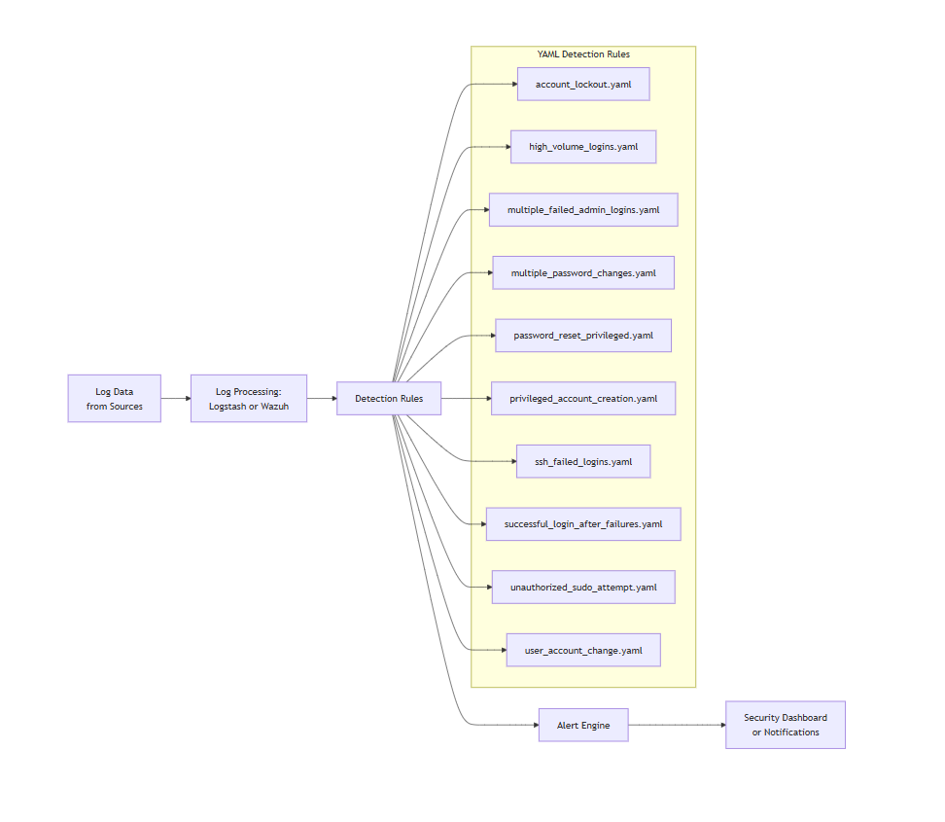
FIGURE:1.1

3.2.2 ACTORS AND USE CASES – SIEM SYSTEM
Actors:
- Security Analyst
Monitors alerts, investigates threats, and responds to incidents.
- System Administrator
Configures data sources, sets up log forwarding, and manages system health.
- SIEM System
Automatically collects, stores, correlates, and analyzes logs to detect suspicious behavior.

Use Cases:
- Ingest Logs from Data Sources
  - Description: Collects logs from firewalls, servers, IDS/IPS, endpoints, etc.
  - Actor: System Administrator
- Parse and Normalize Logs
  - Description: Transforms raw logs into a uniform structure for correlation.
  - Actor: SIEM System
- Real-time Alerting
  - Description: Generates alerts based on correlation rules or anomaly detection.
  - Actor: SIEM System
- View Security Dashboards
  - Description: Displays visual summaries and key metrics of security events.
  - Actor: Security Analyst
- Investigate Security Incidents
  - Description: Enables detailed analysis of logs and traces attack paths.
  - Actor: Security Analyst
- Generate Compliance Reports
  - Description: Exports reports to meet standards such as ISO 27001, PCI-DSS, etc.
  - Actor: Security Analyst
- Tune Detection Rules
  - Description: Modifies correlation and alerting rules to reduce false positives.
  - Actor: System Administrator
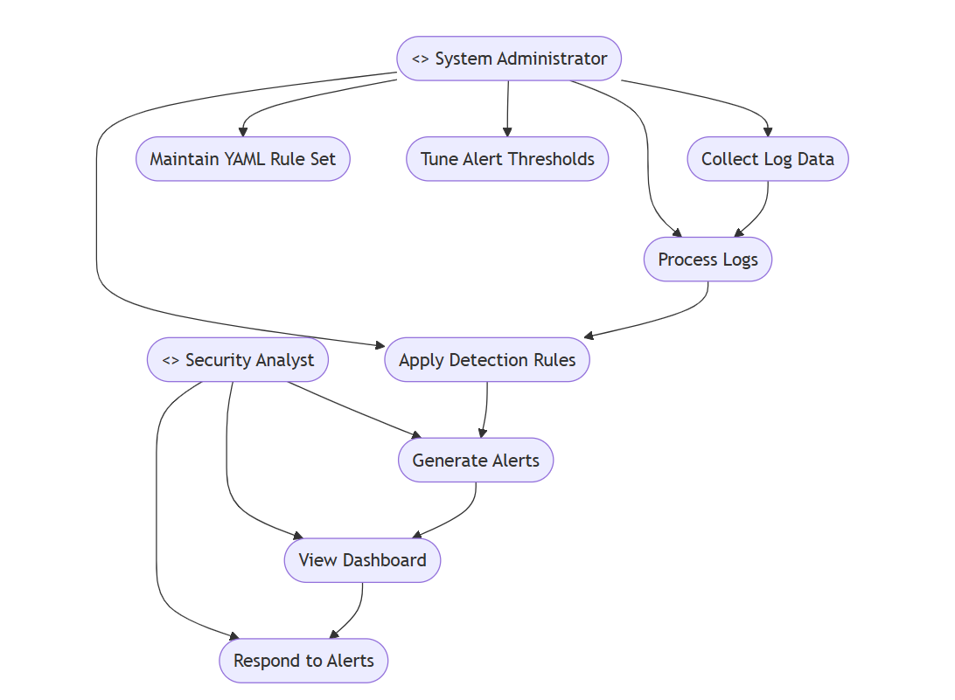
FIGURE :1.2

CHAPTER 4 TESTING
4. TESTING
Thorough testing was conducted to ensure the accuracy, stability, and efficiency of the SIEM system in detecting and reporting security events. The testing process included both unit testing for rule logic and integration testing to validate the end-to-end event flow from log ingestion to alert generation.

4.1 UNIT TESTING
Unit testing focused on verifying the correctness of each rule, parser, and detection mechanism in isolation.
4.1.1 TEST AREAS COVERED
- Log Parsing Rules
Verified YAML-based parsing templates for syslog and JSON-formatted logs from multiple sources (Linux auth logs, web servers, custom applications).
- Detection Rules
Tested detection logic (e.g., multiple failed login attempts, suspicious IPs, missing user-agents) with synthetic log data to ensure triggers fire correctly.
- Threshold Logic
Validated correlation rules that aggregate logs over a time window (e.g., 5 failed attempts within 60 seconds) using mocked event sequences.
- Alert Formatting
Ensured alerts are formatted with accurate timestamps, rule names, severity levels, and affected IPs/usernames.
4.1.2 TOOLS USED
- pytest – for running rule-specific unit tests and coverage analysis
- YAMLlint – to validate syntax and schema of custom rule files
- mock – to simulate streaming log data
- pandas – for validating aggregated event behavior
- elastalert-test-rule – for testing rules (if using ElastAlert or similar framework)

4.2 INTEGRATION TESTING
Integration testing verified the interaction between log ingestion modules, detection engines, and alerting systems.
4.2.1 TEST SCENARIOS
- Brute-force Login Detection
Simulated multiple failed SSH login attempts from the same IP and validated that a high-severity alert was triggered.
- Normal vs. Suspicious Behavior
Compared normal login patterns against simulated anomaly (e.g., login from unknown geographic region/IP) to ensure false positives are minimized.
- End-to-End Flow
Injected real syslog entries through the SIEM pipeline (e.g., via Fluentd or Logstash), verified log normalization, rule matching, and alert generation in Elasticsearch/Kibana.
- Error Scenarios
Tested for missing fields in logs, malformed entries, or network delays between collector and processor components.
4.2.2 TOOLS USED
- Log Generator (custom Python script) – to generate real-time test logs
- Postman – to simulate REST API alerts and check webhook integrations
- Kibana/Graylog – to view and verify alert messages

4.3 BUG TRACKING AND RESOLUTION
- Fixed parsing errors where logs with unexpected whitespace caused misinterpretation of usernames.
- Resolved missing field issues in JSON logs by adding fallback logic in parser.
- Optimized threshold detection to reduce false positives in legitimate multi-login scenarios.
- Addressed delay in alert generation due to buffering issues in log forwarder.
- Improved compatibility with new log sources by dynamically extending parsing rules.

CHAPTER 5 RESULTS

SSH MULTIPLE FAILED LOGIN:
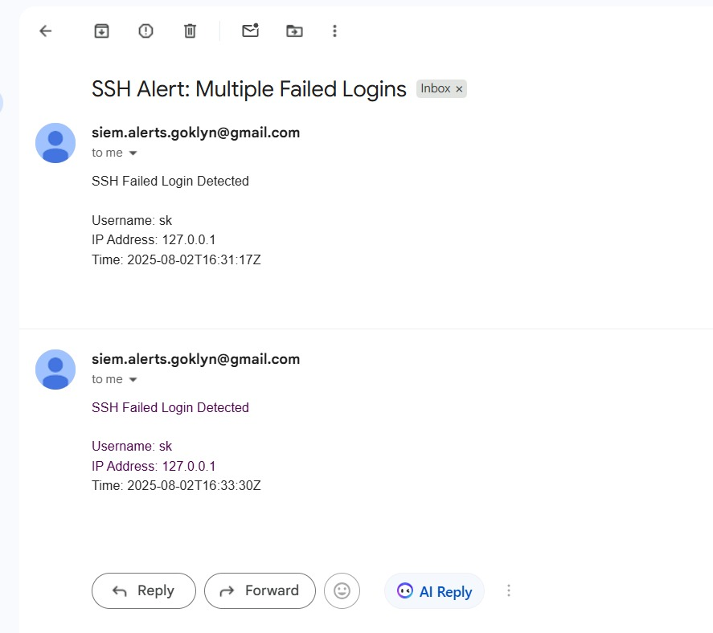

FIGURE:1.3

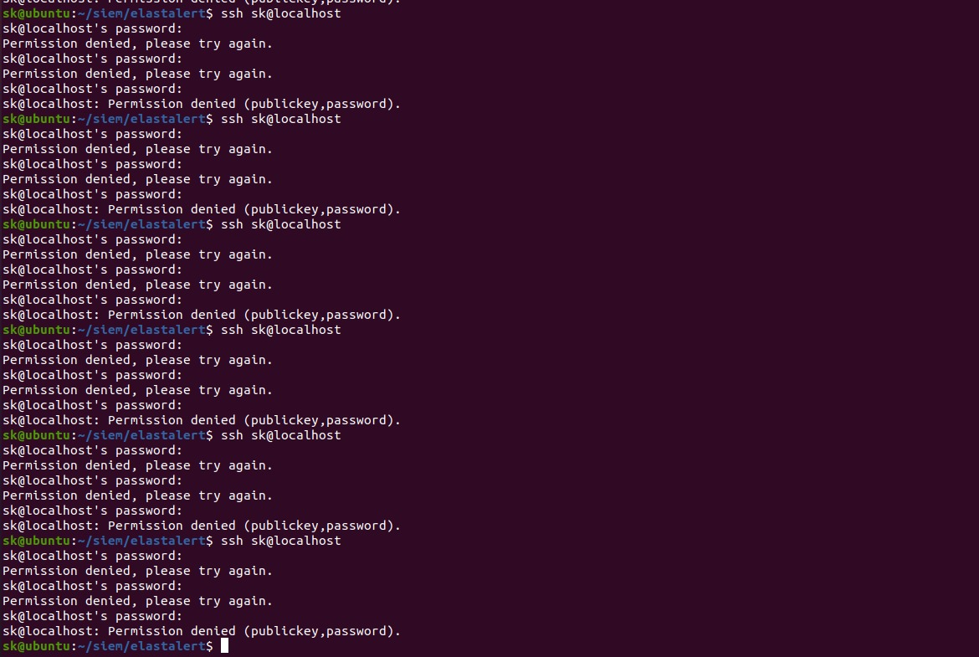

FIGURE:1.4
MULTIPLE FAILED ADMIN LOGIN:
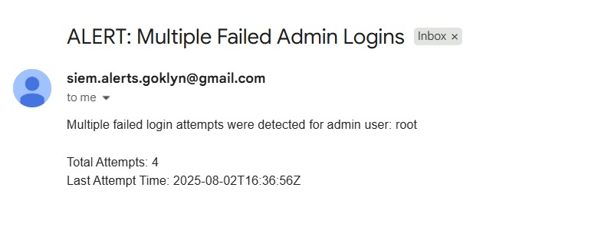

FIGURE:1.5

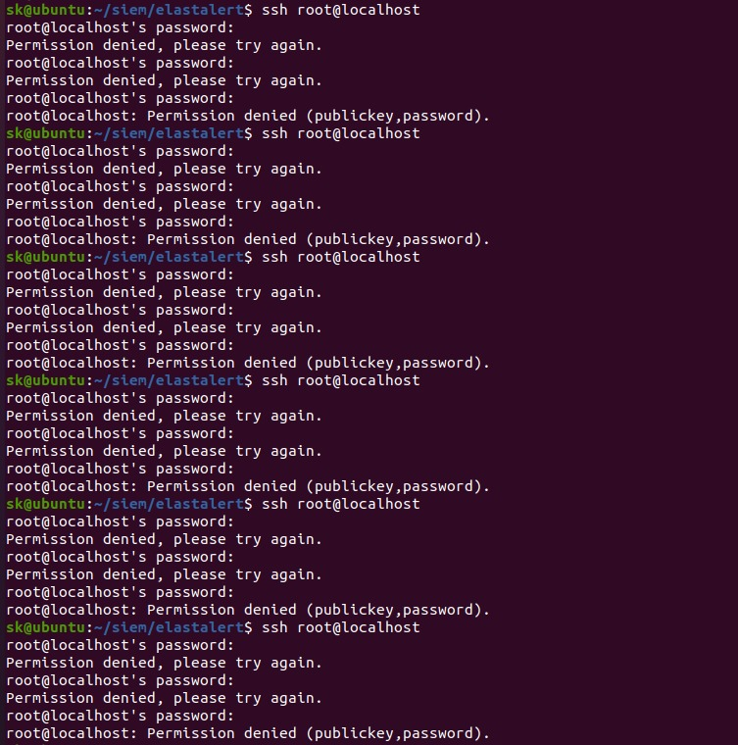
FIGURE:1.6
SUDO ACOOUNT LOCKOUT:
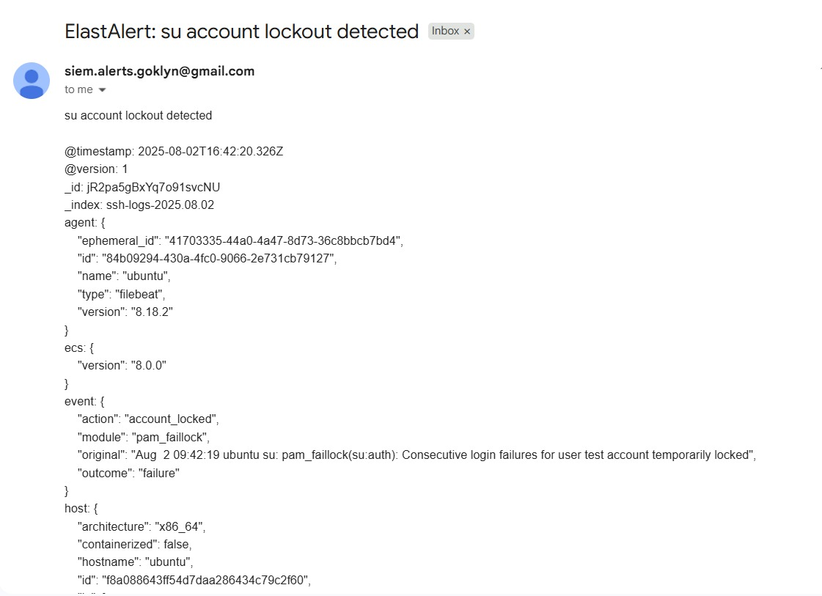
FIGURE 1.7
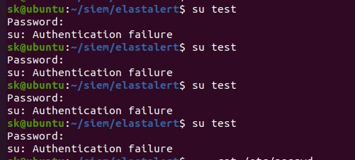
FIGURE 1.8

UNAUTHORIZED SUDO ATTEMPT
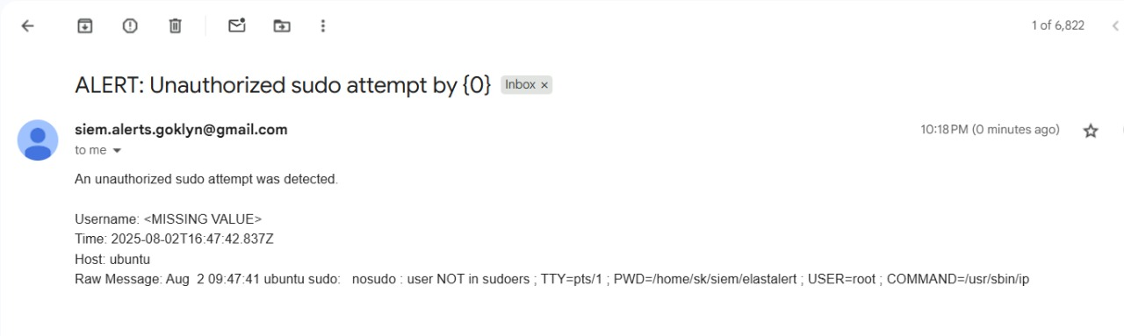
FIGURE1.9
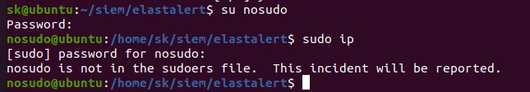
FIGURE 2.0
MULTIPLE PASSWORD CHANGE
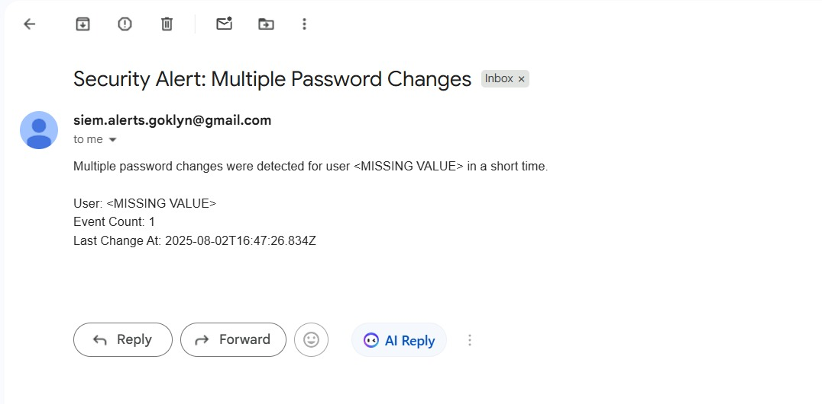
FIGURE2.1
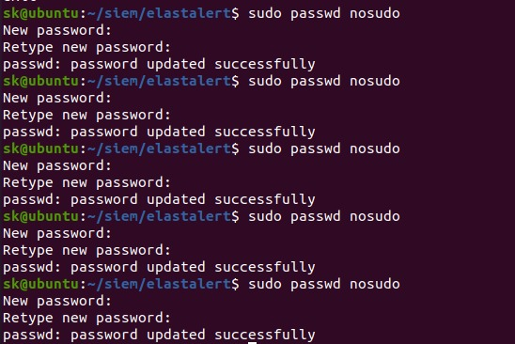
FIGURE2.2

CHAPTER 6 DEPLOYMENT
6.1 PURPOSE
The purpose of this deployment section is to guide the setup of the SIEM system on a local Ubuntu environment. It ensures all components (Elasticsearch, Logstash, Kibana, Filebeat) are properly configured and deployed, enabling effective log collection, analysis, and visualization for real-time threat detection.

6.2 PREPARATION AND PROCEDURE
Before initiating deployment, the following preparations should be completed:
- System Requirements Check:
Confirm system compatibility and ensure adequate memory, storage, and network connectivity to support ELK components.
- Package Configuration:
Prepare the configuration files for:
  - Elasticsearch: Set up cluster name, node roles, and memory limits.
  - Logstash: Configure input, filter, and output pipelines.
  - Kibana: Set up dashboards, default index patterns, and API settings.
  - Filebeat: Define log paths and output to Logstash.
- Network & Security Configuration:
  - Open necessary ports (e.g., 9200, 5601) in the firewall.
  - Secure communication using TLS and authentication if required.

6.3 PRODUCT DEPLOYMENT
Deployment involves setting up and starting all four components on the local machine in the correct order:
- Elasticsearch:
Acts as the core storage and search engine for ingested logs.
- Logstash:
Serves as the data processor, parsing incoming logs and sending them to Elasticsearch.
- Kibana:
Provides a user-friendly interface for visualization and alert configuration.
- Filebeat:
Installed on client or monitored systems to collect logs and forward them to Logstash.
All components are configured to work in tandem for end-to-end data flow and analytics.

6.4 ENVIRONMENT VARIABLES
Environment-specific configurations are necessary to manage secrets and operational parameters securely:
- Elasticsearch
  - Cluster name
  - Path settings for data and logs
  - Heap size and performance tuning variables
- Logstash
  - Pipeline configuration paths
  - API keys for enrichment (e.g., GeoIP)
  - Output destination (Elasticsearch endpoint)
- Kibana
  - Elasticsearch endpoint
  - Index pattern defaults
  - User authentication and roles (if security enabled)
- Filebeat
  - Input paths for log files
  - Output destination (Logstash endpoint)

CONCLUSION

The implementation of the Security Information and Event Management (SIEM) system using the ELK stack—Elasticsearch, Logstash, Kibana, and Filebeat—demonstrated an effective, open-source solution for real-time security monitoring and log analysis. Through this project, we successfully established a centralized platform capable of collecting, processing, storing, and visualizing log data from various sources.
By integrating Filebeat for lightweight log shipping, Logstash for parsing and enrichment, Elasticsearch for powerful indexing and search capabilities, and Kibana for insightful dashboards and alerting, the system allows for early threat detection, anomaly identification, and incident response. The deployment on a local Ubuntu environment emphasized simplicity, cost-effectiveness, and adaptability to small and medium-scale infrastructures.
Overall, this project showcases the importance of SIEM in modern cybersecurity practices and demonstrates how open-source tools can be effectively leveraged to enhance visibility and strengthen organizational security posture.

FUTURE SCOPE
The current implementation of the SIEM system provides a strong foundation for centralized log management and basic threat detection. However, there are several avenues for enhancing its capabilities in the future:
- Integration with Threat Intelligence Feeds: Incorporating real-time threat intelligence sources (e.g., AbuseIPDB, AlienVault OTX) to enrich log data and proactively detect known malicious indicators.
- Advanced Correlation Rules: Implementing custom rule sets or integrating with tools like ElastAlert or Wazuh to detect complex attack patterns and automate responses to potential incidents.
- Machine Learning and Anomaly Detection: Leveraging machine learning models (e.g., via Elasticsearch's ML features or external tools like Splunk ML Toolkit) to identify unusual behavior or zero-day attacks that may go unnoticed with static rules.
- Cloud Environment Monitoring: Expanding the system to monitor logs from cloud-based services (e.g., AWS CloudTrail, Azure Monitor, Google Cloud Logging) to provide a hybrid threat visibility solution.
- Scalability and High Availability: Deploying the system in a distributed architecture to handle larger volumes of data and ensure continuous monitoring without downtime.
- User Behavior Analytics (UBA): Incorporating UBA to monitor and profile user activities, helping detect insider threats or compromised credentials.
- Alert Management and Response Automation: Enhancing the system with SOAR (Security Orchestration, Automation, and Response) capabilities to streamline incident response and reduce manual intervention.
These future enhancements would significantly elevate the SIEM system’s effectiveness, providing deeper insights, broader coverage, and faster reaction to emerging security threats.

REFERENCES
Elastic Stack (ELK) Official Documentation
Comprehensive guide to configuring Elasticsearch, Logstash, Kibana.
https://www.elastic.co/guide/index.html

Wazuh - Open Source SIEM Platform
Integrates with the ELK Stack to provide enhanced threat detection, integrity monitoring, and compliance.
https://documentation.wazuh.com/current/index.html

OWASP Juice Shop
A vulnerable web application used for security training and testing SIEM log collection and detection capabilities.
https://owasp.org/www-project-juice-shop/

ElastAlert Documentation
Tool for creating custom alerts from Elasticsearch data.
https://elastalert.readthedocs.io/en/latest/

MITRE ATT&CK Framework
Knowledge base of adversary tactics and techniques for SIEM mapping.
https://attack.mitre.org/

AbuseIPDB - Threat Intelligence Service
Real-time IP address reporting and checking service for enriching SIEM data.
https://www.abuseipdb.com/

OWASP Log Review Cheat Sheet
Guidelines for secure and effective log analysis.
https://cheatsheetseries.owasp.org/cheatsheets/Log_Review_Cheat_Sheet.html

Kibana SIEM Dashboards – Elastic Security
Ready-made dashboards for security analysis and detection.
https://www.elastic.co/guide/en/security/current/index.html

Medium Article – ELK Stack for Security Monitoring
A walkthrough on using the ELK Stack for log monitoring and detection.
https://medium.com/analytics-vidhya/elk-stack-for-security-monitoring-cfcf0d7d8f26

APPENDIX

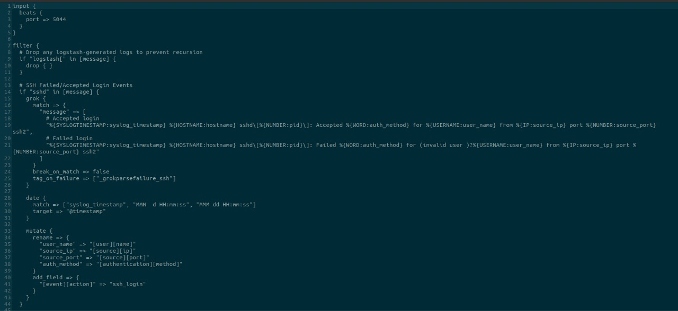
A. Tools and Technologies Used
- Programming Language: Python
- SIEM Stack:
  - Elasticsearch – for storing and searching logs efficiently
  - Logstash – for processing and transforming incoming log data
  - Kibana – for visualizing and analyzing logs in real-time
  - Filebeat – for forwarding and centralizing log data from endpoints
- Web Framework: Flask (for building the dashboard or interface, if applicable)
- Database (optional): MongoDB or SQLite (for auxiliary storage)
- Libraries and Modules Used:
  - os, json, datetime, logging – for file handling and logging
  - requests – for API calls (e.g., pulling data from Juice Shop or external sources)
  - pandas, matplotlib (optional) – for data manipulation or visualization
- Operating System: Linux-based (Ubuntu preferred for ELK stack)
- Deployment: Localhost or cloud-based (AWS/GCP if hosted)
- Security Tools Integrated: OWASP Juice Shop (for generating vulnerable events)

B. Data Sources
- Application Logs – Captured from web applications like OWASP Juice Shop
- System Logs – Syslogs from host machines
- Network Logs – If any, using tools like Suricata or Zeek
- Authentication Logs – Captured from local login systems or mock services

C. Use Cases Implemented
- Detection of suspicious login attempts
- Unauthorized access monitoring
- Alert generation for critical severity vulnerabilities
- Dashboard view of attacks over time (via Kibana)

